TimeZoneDB API

🕒 What Is the TimeZoneDB API?
# Source: AI Source: Provided by: [Data Path: Persons Table -> ID Column: 1, Name_En Column: Motasem Essam] -> From: [ChatGPT] on [1/19/2026]
The TimeZoneDB API is a web service that provides accurate time zone information for any location or IP address in the world.
It helps developers convert times, display local time, and adjust for daylight saving time (DST) based on geographic data.

✅ What TimeZoneDB API Can Do
# Source: AI Source: Provided by: [Data Path: Persons Table -> ID Column: 1, Name_En Column: Motasem Essam] -> From: [ChatGPT] on [1/19/2026]
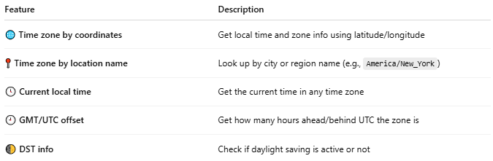

Feature | Description
🌐 Time zone by coordinates | Get local time and zone info using latitude/longitude
📍 Time zone by location name | Look up by city or region name (e.g., America/New_York)
🕓 Current local time | Get the current time in any time zone
🕘 GMT/UTC offset | Get how many hours ahead/behind UTC the zone is
🌓 DST info | Check if daylight saving is active or not

🔗 Base API URL
# Source: AI Source: Provided by: [Data Path: Persons Table -> ID Column: 1, Name_En Column: Motasem Essam] -> From: [ChatGPT] on [1/19/2026]
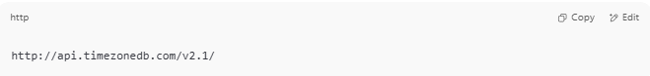
http://api.timezonedb.com/v2.1/

✅ Requires a (free) API key — get one from:
https://timezonedb.com/register

📤 Example: Get Time Zone by Coordinates
# Source: AI Source: Provided by: [Data Path: Persons Table -> ID Column: 1, Name_En Column: Motasem Essam] -> From: [ChatGPT] on [1/19/2026]
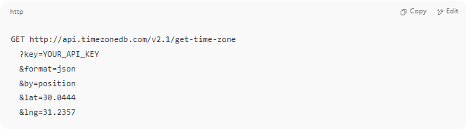
GET http://api.timezonedb.com/v2.1/get-time-zone
?key=YOUR_API_KEY
&format=json
&by=position
&lat=30.0444
&lng=31.2357

(This is for Cairo, Egypt)

📥 Example Response
# Source: AI Source: Provided by: [Data Path: Persons Table -> ID Column: 1, Name_En Column: Motasem Essam] -> From: [ChatGPT] on [1/19/2026]
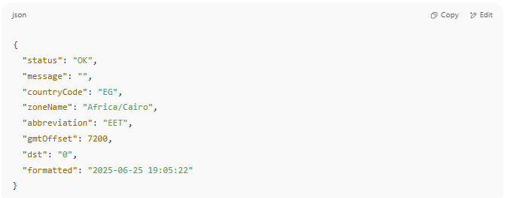
{
"status": "OK",
"message": "",
"countryCode": "EG",
"zoneName": "Africa/Cairo",
"abbreviation": "EET",
"gmtOffset": 7200,
"dst": "0",
"formatted": "2025-06-25 19:05:22"
}

🧪 Other API Modes
# Source: AI Source: Provided by: [Data Path: Persons Table -> ID Column: 1, Name_En Column: Motasem Essam] -> From: [ChatGPT] on [1/19/2026]
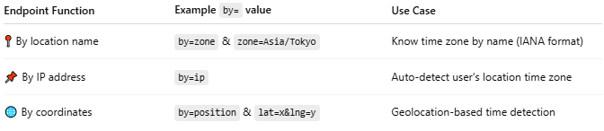

Endpoint Function | Example by= value | Use Case
📍 By location name | by=zone & zone=Asia/Tokyo | Know time zone by name (IANA format)
📌 By IP address | by=ip | Auto-detect user's location time zone
🌐 By coordinates | by=position & lat=x&lng=y | Geolocation-based time detection

🛠 Use Cases
# Source: AI Source: Provided by: [Data Path: Persons Table -> ID Column: 1, Name_En Column: Motasem Essam] -> From: [ChatGPT] on [1/19/2026]
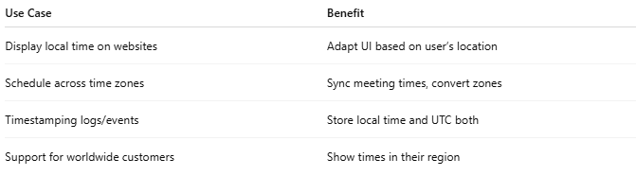

Use Case | Benefit
Display local time on websites | Adapt UI based on user’s location
Schedule across time zones | Sync meeting times, convert zones
Timestamping logs/events | Store local time and UTC both
Support for worldwide customers | Show times in their region

💰 Pricing
# Source: AI Source: Provided by: [Data Path: Persons Table -> ID Column: 1, Name_En Column: Motasem Essam] -> From: [ChatGPT] on [1/19/2026]
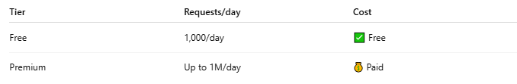
Tier | Requests/day | Cost
Free | 1,000/day | ✅ Free
Premium | Up to 1M/day | 💰 Paid
🔗 Compare plans here: https://timezonedb.com/api

